#1

This assessment can simply be completed by clicking the reset password button

Orrrr……..

#1

Start off by sending a password reset to yourself

#2

Click the link to the webpage that displays this is not for the admin account

#3

#4

Next you have to find this source code on github that displays the hash value for the admin account needed for the request

#5

Intercept the link request from the webwolf email through burpsuite and manipulate the hash to the hash value of the admin account from the github source code

#6

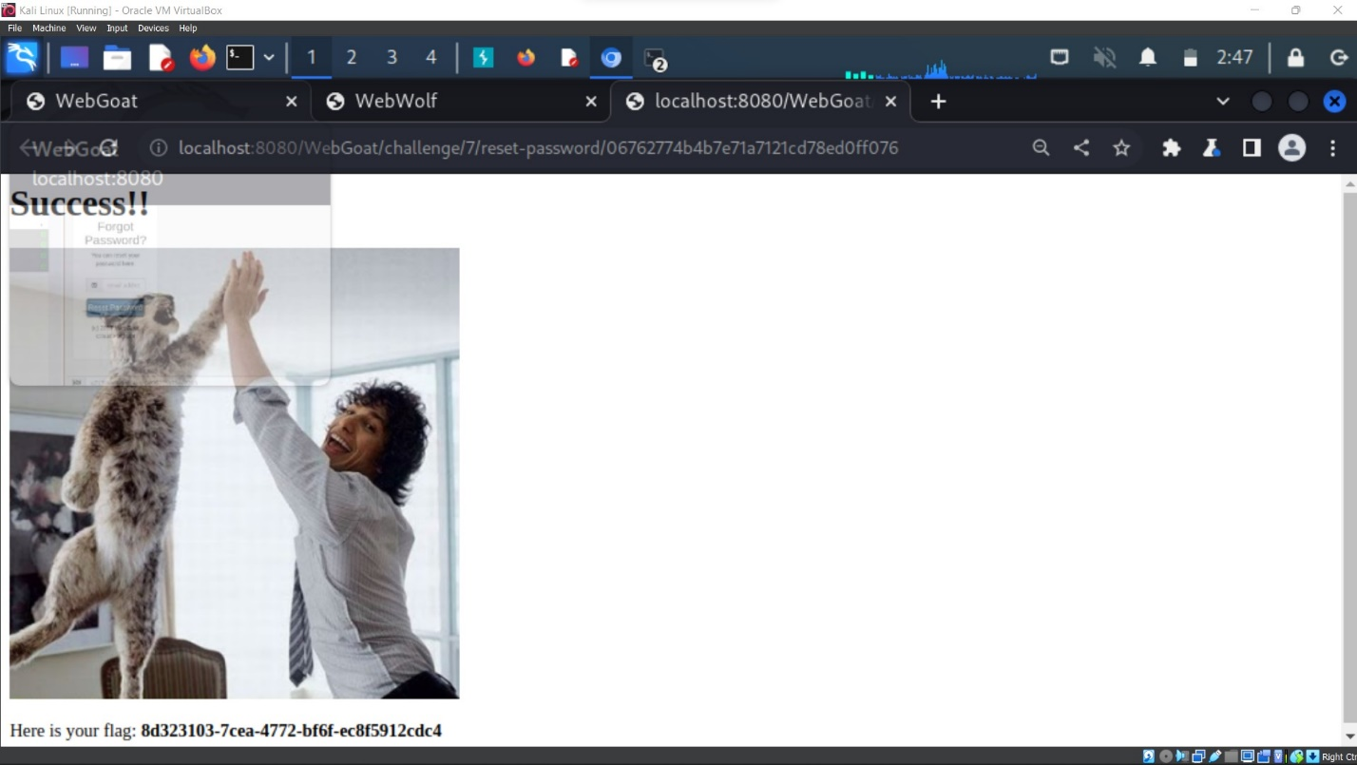Success!

#7

Success pt.2!!!